String Superprimivitity Test on the Reconfigurable Bus Model
Introduction
A string is primitive : 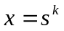 implies 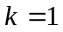
Ex : aba, abce

A primitive string is a period of another string : 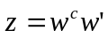
constant 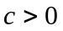, 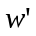 : a possibly empty prefix
Ex : abc is a period of abcabcabca

A substring of is called a cover of if can be constructed by concatenations and superpositions of .
Ex : abca is a cover of abcabcaabca

A string that is covered only by itself is superprimitivite.
Ex: aba, abaab

A string is covered by 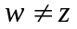, then is quasiperiodic
Ex: abaababa

A substring of is called a seed of if there exists a superstring of which is constructed by concatenations and superpositions of .
Ex: abca is a seed of abcabcaabc

A string is a border of string if is simultaneously a prefix and a suffix of .
Ex: abaab is a border of abaabaab

Our method :

step1.Finding a border of string that its length is maximal
step2.Testing whether the border covers the string

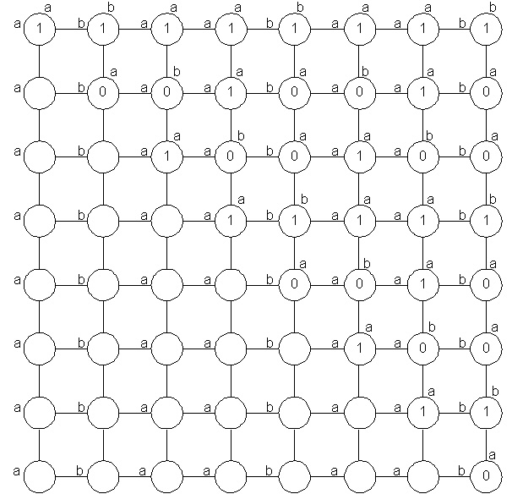
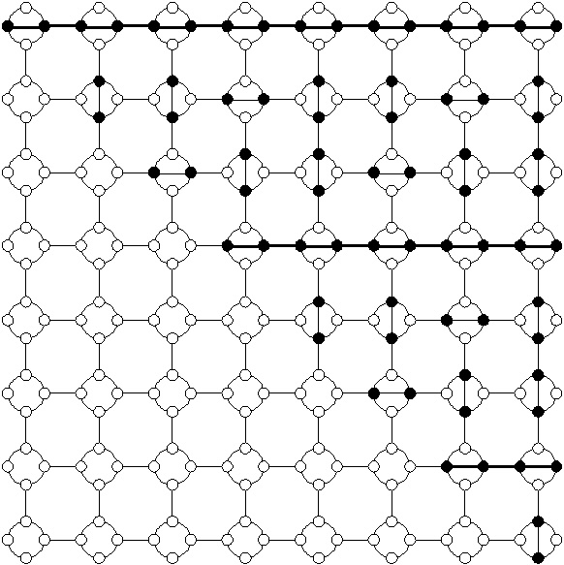
step1 :
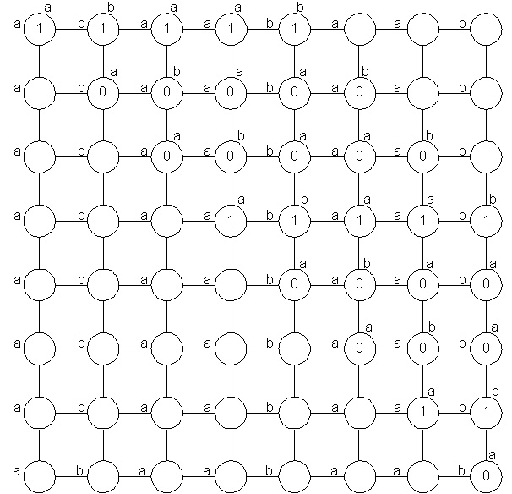
step2 :
